IT -OT Convergence

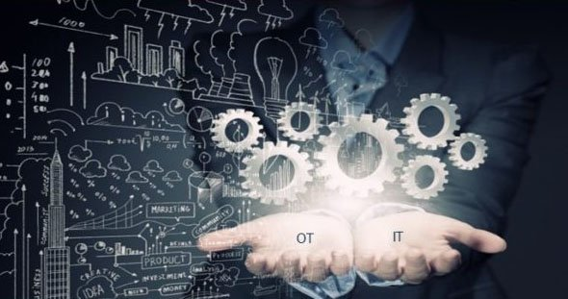

Highlights:

* IT-OT convergence
* How Internet of Things(IoT) brings about the convergence
* Resolving the challenges of IT -OT convergence
* How industries benefit from IT-OT convergence
* IT-OT convergence as the factory of the future

IT -OT convergence

IT and OT have always had different priorities specially in terms of defining and balancing risks . IT , for example, uses the CIA (confidentiality, integrity and availability) model to prioritize data protection whereas for OT , the safety of workers and availability of systems is the top priority. However , with the rise of the Internet of Things(IoT) and Industry 4.0 , the integration and aligning of IT and OT has become a necessity.

**So ,what is this convergence?**

IT/OT convergence , in layman’s terms is the convergence of Information Technology systems and Operational technology. It comprises integration of data from the systems that handle computing and data processing (IT) with data from systems that directly control and look over manufacturing and other industrial operations(OT).

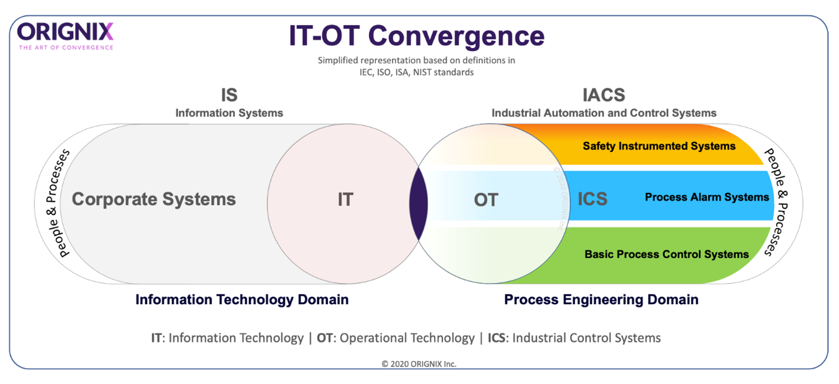

How Internet Of Things brings IT and OT together?

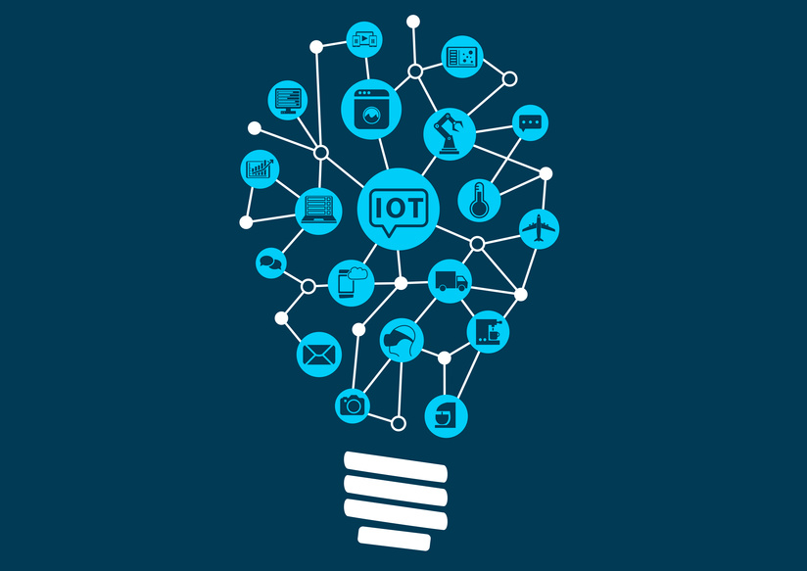

IT and Ot have a complicated history that goes way back to the time they were developed , both for completely different tasks . But the biggest setback was that neither was designed to work with the other. Now this is where Internet of Things comes into the picture. The lines between IT and OT is blurring and the IoT is higly responsible for this. The gap between IT and OT prevents them from having the required data at the time of relevance . Not being able to connect and share data within or across an organization results in poor decision-making abilities . Now ,IoT bridges this gap by enabling the sharing and usage of right data at the right moment , conveniently and freely .

Huge number of devices are already connected to the Internet of Things and new are becomimg a part of this network daily. Iot makes it possible to collect , share and comprehend the essential data required by those working with OT systems . IoT is like the glue which holds together critical functions and provides for communication with increased ease. Leveraging IoT ensures that IT and OT systems cans use data to make important decisions and anticipate any potential threats or impacts. Not only does it facilitate to use data to optimize busiess processes but also minimizes business risks and risks of sudden machine failures.

Major benefits of IoT supporting the convergence of IT and OT:

* Lower operating costs
* Shorter development time and availability of common platforms
* Briges critical gap between people and processes
* Provides for security across all networks
* Business decisions are greatly optimized

What are the biggest challenges manufacturers face in IT-OT convergence?

It is one to say “ We need to have a policy to manage data” that will outline how and where analytics functions are formed and another to actually create and implement it. Some of the challenges faced by the manufacturers in implementing the convergence are:

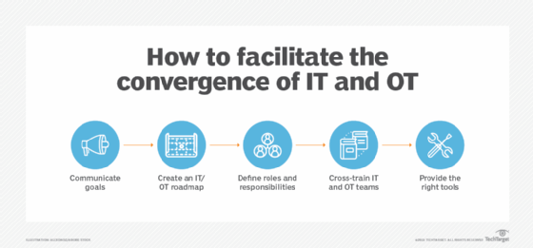

|  |  |  |
| --- | --- | --- |
| CHALLENGES | OVERVIEW | SOLUTION |
| * Cyber-security challenges- | **Convergence of IT-OT gives external world access to GCD operations that can be exploited by data hacker.** | **Set up IT infrastructure with smart filtering and deploy zero-trust authentication** |
| * Scalability issues | **Edge devices may collectively flood an IT infrastucture with more data than it can handle.** | **Additional intermediary infrastructures or cloud service can help** |
| * Resisatnce and different perspective | **IT and OT have different priorities which has resulted in strong internal resistance with mistrust coming from both sides** | **Careful planning , co-ordination, open communication and effective listening**   * **Strategic executive alignment** * **Establishing a joint task force** * **Early cross trainings** |
| * Change-management capabilites | **IT-OT integration requires significant and ongoing chain management** | **Operations department need to be trained around new technologies and possibilities that emerge with IT-OT integration** |
| * Lack of a clear roadmap | Organization level strategy often lacks a suitable architecture for technology adoption | In the absence of a suitable roadmap, IT-OT systems continue to run as stand alone systems. |
|  |  |  |

HOW INDUSTRIES BENEFIT FROM IT-OT CONVERGENCE

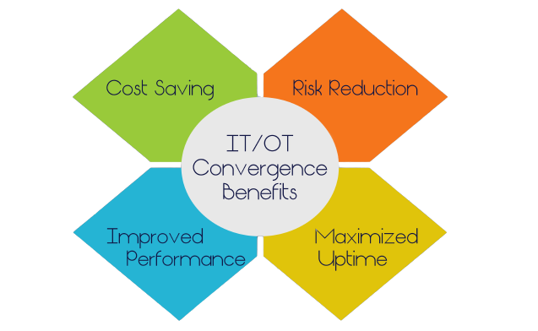

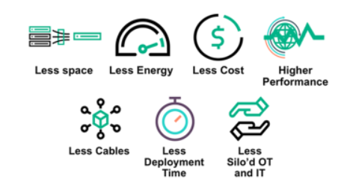

* **Implementation and management made convenient** : With the advent of commonplace Wi-Fi and the availability of 5G technologies , there is no longer need of complex networking setups and management systems.
* **Integrated Simplified Controls** : IT-OT convergence implies that control and data access is not the strong point of just a particular group of peole but everyone has equal abilty t manage and control systems.
* **Quick access of data in real time** : The OT component of an organization has access to the data and storage functions of IT which provides greater transparency to the operators and enables more effective decision-making.
* **Increased scope for improvement:** The idea in IT-OT convergence is to replace complexities with simplicity. This in turn ensures that the employees have access to to available data and control systems to understand and explore more innovative ways to enehance quality and productivity.

IT-OT convergence as the factory of the future

IT-OT convergence not only enables Industry 4.0 but also acts as a key that would help companies attain the vision of “factory of future “. The greatest hurdle today for most manufacturers is to maintain the balance between IT and OT. And it goes without saying that in order to optimize operational efficiency and overcome potential disruptions , convergence of both the systems is a necessity. The most important facet of the convergence is that the IT and OT people would collaborate to solve combinatorial problems.

Some of the proceed through the convergence that will drive impacts are:

* Enabling real-time decision making through fog computing
* Deploying wireless technologies on the factory floor
* Elimination of unplanned downtime
* Improved operational efficiency and optimized profitability
* Enabling digital transformation
* Ensuring cybersecurity for a new world of connected machines.
* Value Creation:
* Data Privacy

Thus IT-OT convergence plays a major role in establishing a digital manufacturing transformation by integrating OT technologies with that of IT . The integration of IT and OT is transforming manufacturing industry in ways neither function could have imagined , all the while making both units more efficient at their jobs and marching forward to make it the factory of manufacturing.

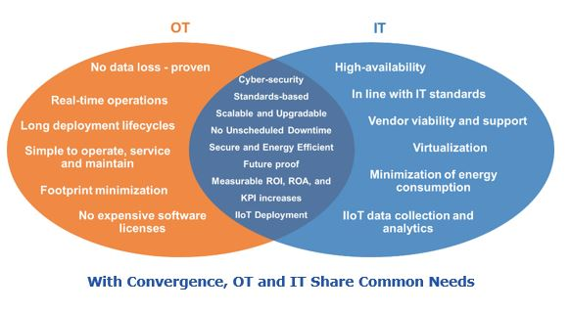

Conclusion:

IT-OT convergence might appear a bit overwhelming in the beginning . However , it is an essential step that needs to be taken for reaping the benefits of IIoT. While , given the history of IT and OT relationship , resistances and mistrust issues are bound to arise but if those are overcome the wonders that the integration of IT and OT can bring around is worth the effort.